**Roll No: 1803067**

**Lab Performance Test 1**

**Lab Task Q1 , Q2a , Q2b**

**Question:**

Q1. Consider given code, #include<math.h> int main(){ float a=1; float b=2; float c=a+b; return 0; } . Show output file with extension ".s" generated by C compiler along with Makefile (point penalty for adding extra commands other than necessary).  
  
Q2. Consider given statements, 1. We bought 1 Apple 2.  You sold 50 Mangoes  3. We Wanted 0 Oranges. a) Show a flex file which can tokenize given statements. b) Show a bison file which can parse given statements.

**Q1. Solution (Bold your own written code):**

|  |
| --- |
| all:      gcc -E code.c > code.i      gcc -S -masm=intel code.i |

**Output (Screen/SnapShot):**

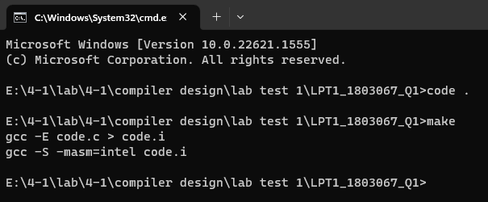

**Q2A. Solution (Bold your own written code):**

|  |
| --- |
| .l  %option noyywrap  %{  %}  %%  "1"|"50"|"0"   {printf("ADJ =>%s\t",yytext);}  "We"|"You"   {printf("N =>%s\t",yytext);}  "bought"|"sold"|"Wanted"   {printf("V =>%s\t",yytext);}  "Apple"|"Mangoes"|"Oranges" {printf("O =>%s\t",yytext);}  %%  int main()  {      yylex();      return 0;  }  Makefile  main:      flex flex.l      gcc lex.yy.c      a.exe <input.txt |

**Output (Screen/SnapShot):**

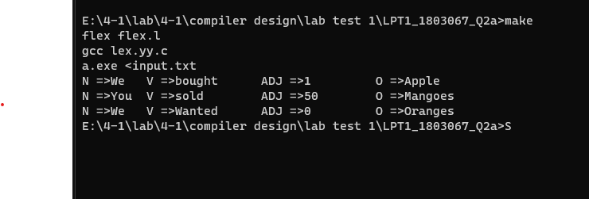

**Q1. Solution (Bold your own written code):**

|  |
| --- |
| .l file  %option noyywrap  %{      //roll : 1803067  #include "bison.tab.h"  %}    %%  **"1"|"50"|"0"   {return(ADJ);}**  **"We"|"You"   {return(N);}**  **"bought"|"sold"|"Wanted"   {return(V);}**  **"Apple"|"Mangoes"|"Oranges" {return(O);}**  . {}  %%  .y file  %{  #include<stdio.h>  void yyerror(char *s);  int yylex();  %}  %token N V O ADJ  %start S  %%  S: S A | A  A: N V O | N V ADJ O;  %%  int f=1;  int main()  {        //roll : 1803067        yyparse();      if(f)      {          printf("Accepted\n");      }      return 0;  }  void yyerror(char *s)  {      f=0;      fprintf(stderr, "<---- error: %s\n", s);  }  Makefile  main:      bison -d bison.y      flex flex.l      gcc bison.tab.c lex.yy.c      a.exe <input.txt |

**Output (Screen/SnapShot):**

